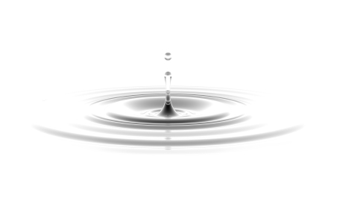
Water Lab

Hydrologist (#): ________________________ Date: ____________

Cross-cutting
- Explanations of stability and change in natural or designed systems can be constructed by examining the changes over time and processes at different scales, including the atomic scale. (MS-ESS2-1)
Disciplinary core
- The planet’s systems interact over scales that range from microscopic to global in size, and they operate over fractions of a second to billions of years. These interactions have shaped Earth’s history and will determine its future. (MS-ESS2-2)
Science and engineering
- Develop a model to describe unobservable mechanisms. (MS-ESS2-4)
- Constructing explanations and designing solutions in 6–8 builds on K–5 experiences and progresses to include constructing explanations and designing solutions supported by multiple sources of evidence consistent with scientific ideas, principles, and theories.
  - Construct a scientific explanation based on valid and reliable evidence obtained from sources (including the students’ own experiments) and the assumption that theories and laws that describe nature operate today as they did in the past and will continue to do so in the future. (MS-ESS2-2)

Station #1

Prediction: How many pennies can you add to a full cup of water? ____

Procedure: Fill a clear plastic cup with water until it is even with the rim. Add pennies, one at a time. Keep track of the number of pennies added. Continue until the water spills over the side. Repeat for the other team member. Record observations.

Observation: Draw the surface of the water.

How many pennies did you add to the cup? Test #1:____ Test #2: ____

Explain: How would you explain what you are seeing? ______________________________________________________________________________________________________________________________________________________________________________
Station #2

Prediction: How many drops of water can you place on a penny before it overflows? ____

Procedure: Using a pipette, place as many drops of water on the penny as possible without spilling over the edge. Keep track of the number of drops. Continue until water spills over or the water drop collapses. Repeat for the other team member. Record observations.

Observation: Draw the surface of the water on the penny.

How many drops of water did you add to the surface of the penny?
Test #1: ____ Test #2: ____

Explain: How would you explain what you are seeing? ______________________________________________________________________________________________________________________________________________________________________________

Station #3

Prediction: How many paper clips do you think you can suspend on the surface of the water? ______

Procedure: Try placing a paper clip on the surface of the water (Hint: easier to use a fork). Observe the water where it comes in contact with the paper clip. Describe what the water looks like.
____________________________________________________________________________________________________________________

Explain: Why does the water look like this?
______________________________________________________________________________________________________________________________________________________________________________

Station #4

Prediction: How long will it take your boat to make it across the container? _____

Procedure: Place your boat in an uncontaminated container of water. Use a toothpick to place a small amount of dish soap in the water in the triangle cut in the back of the boat. When the soap touches the water, start the timer. When the boat makes it to the other side, stop the timer. Record the time: _____

Explain: Why does the boat move across the water?
______________________________________________________________________________________________________________________________________________________________________________

Station #5

Procedure: Pour whole milk on the surface of paper plate. Place four drops of food coloring in the four quadrants of the milk. Place a toothpick with dish soap in the center of the plate.

Describe what you see:
____________________________________________________________________________________________________________________

Why do you think this happened?
______________________________________________________________________________________________________________________________________________________________________________

